**MIS 6380.501**

**DATA VISUALIZATION ​**

**Prof. Naser Islam**

**"Impacts of COVID-19: Evaluating Lockdown Strategies, Energy Usage Shifts, Electric Vehicle Adoption, and Supply Chain Resilience."**

Group 4 :​

1. TZU YEN KU​
2. HRUSHIKA NARESHKUMAR SAMALA​
3. SHREYAS SANPURKAR​
4. JAYANTH BANDARU​
5. JAYA SAI SIVANI MANGAMURI​
6. TARA CANUGOVI​

**INDEX**

1. Executive Summary - - - - - - - - - - - - - - - - - - - - - - - - - - - - - - - - - - - - - - - - -3
2. Data Description - - - - - - - - - - - - - - - - - - - - - - - - - - - - - - - - - - - - - - - - - - - 4
3. Data Cleaning - - - - - - - - - - - - - - - - - - - - - - - - - - - - - - - - - - - - - - - - - - - - - 6
4. General Introduction - - - - - - - - - - - - - - - - - - - - - - - - - - - - - - - - - - - - - - - 7
5. Insights & Findings - - - - - - - - - - - - - - - - - - - - - - - - - - - - - - - - - - - - - - - - - 8

* Hypothesis 1- - - - - - - - - - - - - - - - - - - - - - - - - - - - - - - - - - - - - - - - - - - - - - 8
* Hypothesis 2- - - - - - - - - - - - - - - - - - - - - - - - - - - - - - - - - - - - - - - - - - - - - - 9
* Hypothesis 3- - - - - - - - - - - - - - - - - - - - - - - - - - - - - - - - - - - - - - - - - - - - - -10
* Hypothesis 4 - - - - - - - - - - - - - - - - - - - - - - - - - - - - - - - - - - - - - - - - - - - - - 11
* Hypothesis 5 - - - - - - - - - - - - - - - - - - - - - - - - - - - - - - - - - - - - - - - - - - - - - 14
* Hypothesis 6 - - - - - - - - - - - - - - - - - - - - - - - - - - - - - - - - - - - - - - - - - - - - - 15

1. Conclusion - - - - - - - - - - - - - - - - - - - - - - - - - - - - - - - - - - - - - - - - - - - - - - -16

**Executive Summary**

The COVID-19 pandemic has triggered significant changes across various sectors in the U.S., forcing industries to adapt to new realities. This project explores the profound effects of the pandemic on public health, energy consumption, consumer behavior, and the automotive industry, leveraging datasets from trusted sources like Kaggle and data.gov.

Our investigation reveals critical trends and shifts:

* **Restaurant Industry**: The pandemic led to a sharp decline in restaurant reviews, reflecting a broader societal shift away from dining out. With increasing fears of the virus, consumers reduced their frequency of dining at restaurants, causing a noticeable drop in restaurant traffic across the U.S.
* **Public Health and Lockdown Impact**: A comparison between New York and Florida’s lockdown strategies during the early stages of the pandemic shows a significant difference in case growth. New York’s early intervention resulted in a slower increase in cases, while Florida, with delayed measures, saw a more substantial rise. This contrast highlights the importance of timely public health responses in controlling the spread of infectious diseases.
* **Energy Consumption Trends**: The pandemic induced notable fluctuations in energy demand. In California, the rise in residential electricity prices was driven by remote work and increased home energy use. In contrast, Hawaii experienced a drop in both residential and commercial energy demand, as its tourism-based economy suffered due to travel restrictions.
* **Electric Vehicle Market**: The automotive industry has seen a shift toward electric vehicles (EVs), with Battery Electric Vehicles (BEVs) experiencing remarkable growth, outpacing Plug-in Hybrid Electric Vehicles (PHEVs). The growth in BEVs aligns with advancements in battery technology and a broader societal push toward sustainability, as consumers increasingly prioritize zero-emission transportation.
* **Supply Chain Disruptions**: The pandemic revealed vulnerabilities in supply chains, most notably with the surge in demand for essentials like toilet paper, driven by panic buying. Cities such as New York, California, and Texas faced significant supply shortages, highlighting the need for more resilient and adaptable supply chain systems in future crises.

This project offers valuable insights into the broad-ranging effects of the pandemic on various industries and consumer behavior, providing a roadmap for navigating post-pandemic recovery and preparing for future disruptions.

**Data Description**

Data sources:

1. <https://covidtracking.com/data/state/new-york>

* Records: Around 5500.
* Description: This dataset contains daily COVID-19 data for the state of New York, offering a comprehensive overview of the pandemic's impact. It includes fields such as the number of positive cases, negative cases, total tests conducted, and pending results, along with hospitalization and ICU admission counts. Additionally, it provides data on fatalities, recovered cases, and the specific reporting date for each entry. Sourced from the COVID-19 Tracking Project under the Apache License 2.0, this dataset spans the years 2020 and 2021, capturing data from the onset of the pandemic through its subsequent waves.

1. <https://covidtracking.com/data/state/florida>

* Records: Around 6500.
* Description: This dataset presents daily COVID-19 data for the state of Florida, offering a detailed perspective on the pandemic's effects. It includes information such as the number of confirmed positive cases, negative test results, total tests administered, and tests with pending outcomes, alongside data on hospitalizations and ICU admissions. In addition, the dataset provides statistics on fatalities, recovered cases, and the specific reporting date for each entry. Compiled by the COVID-19 Tracking Project and released under the Apache License 2.0, the dataset covers the period from the beginning of the pandemic in early 2020 until March 7, 2021, when data collection ended.

1. <https://catalog.data.gov/dataset/annual-electricity-price-by-state>

* This dataset provides annual average electricity prices across U.S. states and regions, with key metrics such as price per kilowatt-hour (kWh). It spans multiple years, enabling analysis of temporal trends and regional disparities, making it valuable for policymakers and energy analysts.
* **Records:** Over 4,500.

1. <https://www.kaggle.com/datasets/fahadsyed97/us-covid19-dataset>

* The dataset focuses on COVID-19 cases and deaths in the USA from January 1, 2020, to January 31, 2021. It includes data on several states, such as Kentucky, Texas, Florida, and Washington, detailing the pandemic's progression and severity.
* Covering the period from January 1, 2020, to January 31, 2021, this dataset highlights COVID-19 cases and deaths across diverse states, providing comprehensive insights into the pandemic.

1. <https://www.kaggle.com/datasets/fahadsyed97/restaurant-reviews?select=precovid_reviews.csv>

* The data is divided into two main parts: pre-COVID and post-COVID. The pre-COVID data includes customer reviews from the past 24 years, covering the period before the pandemic started, while the post-COVID data comprises reviews generated between January 1, 2020, and January 31, 2021.
* Specific steps were undertaken to extract and organize the relevant data for the study, ensuring accurate representation of customer reviews across the pre-COVID and post-COVID timeframes.

1. <https://catalog.data.gov/dataset/electric-vehicle-population-data>

* Records: 170,000.
* Description: This dataset offers a comprehensive view of Battery Electric Vehicles (BEVs) and Plug-in Hybrid Vehicles (PHEVs) registered through the Washington State Department of Licensing (DOL). It includes vital specifications for each vehicle, such as make, model, production year, and current registration status. The data provides an opportunity to analyze trends in electric and hybrid vehicle adoption, evaluate the lifecycle and distribution of vehicle types across the state, and assess the evolution of sustainable transportation within Washington. The dataset's potential uses are vast, from understanding vehicle retention patterns to predicting the growth trajectory of electric mobility.

1. <https://data.cdc.gov/Administrative/Provider-Relief-Fund-COVID-19-Nursing-Home-Quality/bfqg-cb6d/about_data>

* Records: 33,400
* Description: This dataset focuses on demographics, state and city infection statistics and financial indicators related to Covid-19 Provider Relief Fund to Nursing facilities from September to December in the year 2020. The data shows an infection rate, coupled with high financial support, showing a relief adaptive distribution in line with. It also demonstrates a shift in spending across time, peaking in November 2020, which coincides with the national case peak and may signal a concerted effort to keep up the infrastructure of the hospitals during critical periods.

**Data Cleaning**

Step 1: Inspect the Data:

* Open the CSV file in Excel to check for issues like blank cells, missing headers, or inconsistent formats.
* In Python, load the data using Pandas and review it using functions like info(), head(), and describe() to identify potential problems.

Step 2: Handle Missing Values:

* Use Excel’s "Go To Special" feature to find and fix blank cells.
* In Python, use Pandas: fillna() to fill missing values with a default value, dropna() to remove rows or columns with too much missing data.

Step 3: Remove Duplicate Entries:

* In Excel, use the "Remove Duplicates" feature to delete duplicate rows.
* In Python, apply the Pandas drop_duplicates() function to remove redundant records.

Step 4: Fix Data Types:

* Ensure all columns have consistent types (e.g., dates, numbers) in Excel.
* In Python, use Pandas: astype() to convert to the correct type,to_datetime() for date columns.

Step 5: Clean Text Data:

* In Excel, use TRIM() to remove extra spaces and UPPER() to standardize case.
* In Python, clean text with Pandas string methods like str.strip() (remove spaces) and str.lower() (convert to lowercase).

Step 6: Handle Outliers:

* Use Excel charts to visually spot unusual values.
* In Python, detect and handle outliers with statistical tools in Pandas, either adjusting or removing them.

Step 7: Split or Combine Columns:

* Split combined data in Excel using "Text to Columns" or formulas.
* In Python, use Pandas str.split() to separate data and concat() to merge columns.

Step 8: Remove Irrelevant Data:

* Delete unnecessary rows or columns in Excel.
* In Python, use Pandas drop() to remove irrelevant data easily.

**General Introduction**

The COVID-19 pandemic has left an indelible mark on industries, economies, and daily life, reshaping behaviors and creating challenges that continue to unfold. This project aims to analyze the profound effects of the pandemic across key sectors, using data from reliable sources like Kaggle and data.gov to uncover patterns and provide insights into these unprecedented times.

Our research covers a wide range of areas. We examine the behavioral shift in dining habits, where fear of the virus led to reduced restaurant visits across the U.S. We explore the effectiveness of early lockdown measures, comparing states like New York, which acted swiftly, to Florida, where delayed interventions resulted in differing public health outcomes. The project also delves into energy consumption trends, revealing how remote work drove up electricity prices in California, while Hawaii's tourism-dependent economy saw a decline in energy demand and prices.

Additionally, we highlight Tesla’s role in accelerating electric vehicle adoption, showcasing how advancements in battery technology and consumer preferences for zero-emission vehicles have shaped the automotive industry. In the healthcare domain, we evaluate nursing home performance in California during the pandemic, where better outcomes were observed despite the state’s high infection rates.

Lastly, we analyze the supply chain disruptions seen during the peak of the pandemic, such as toilet paper shortages driven by consumer stockpiling behaviors.This report not only seeks to understand the changes brought about by the pandemic but also aims to provide actionable insights for industries and policymakers. By identifying trends and drawing comparisons across sectors, this research offers a roadmap to navigate the challenges of a post-pandemic world and prepare for future disruptions.

**Insights & Findings**

**Hypothesis 1: In the USA, from January 2020 to December 2020, people were afraid of COVID-19 so they reduced the frequency of going to restaurants.**

People love leaving reviews at restaurants, whether they are positive or negative. As a result, the number of reviews can reflect the number of people dining at the restaurant.

Since January 2020, there were a few initial cases of COVID-19 infections, and during this period, the number of reviews for restaurants began to decline. This decrease in reviews indicated that people were becoming increasingly concerned about dining out due to the growing threat of the virus. Between February and April, the number of infection cases saw a significant increase, which directly influenced people's behavior. During this time, there was a sharp decline in the number of restaurant reviews, reflecting widespread fear and hesitation about dining at public establishments. This trend highlights how the pandemic drastically affected consumer habits and social behavior.

In conclusion, based on the data, you can notice that infection cases and reviews are negative correlation, so we cannot reject the hypothesis.

**Hypothesis 2: In March 2020, early implementation of COVID-19 lockdown measures in New York led to a slower increase in new cases compared to Florida, where delayed lockdowns resulted in higher infection rates.**

Due to the early implementation of COVID-19 lockdown measures in March 2020, New York experienced a 55% increase in COVID-19 cases, rising from approximately 457,174 to 11,609,403 by March 2021. In contrast, Florida, which delayed its lockdown until April, saw a 61% increase in cases, growing from around 28,389 to 13,257,122 during the same period. This stark difference in case growth highlights the potential impact of timely lockdown measures on controlling the spread of the virus.

The comparison between New York's early response and Florida's delayed approach underscores the critical role of swift interventions in pandemic management. Early lockdowns correlate with a slower rise in cases, reducing the peak impact of the pandemic and potentially saving lives. These findings emphasize the importance of proactive measures in minimizing the spread of infectious diseases like COVID-19 and provide valuable insights for managing future public health crises.

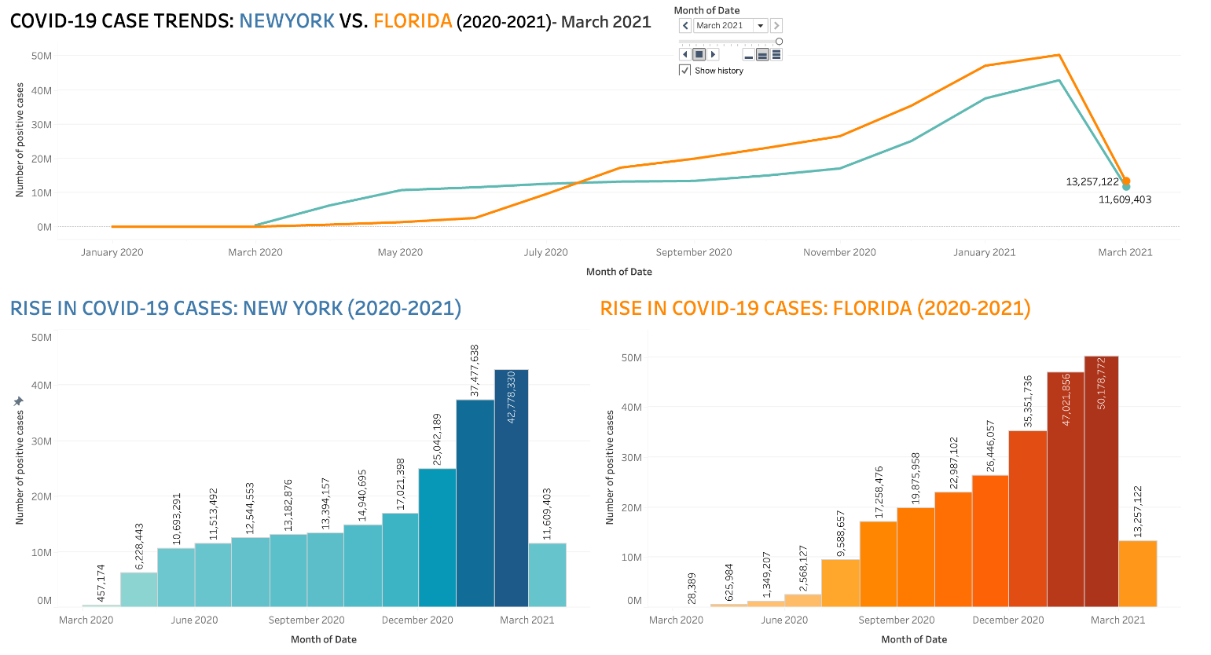

**Hypothesis 3: In 2020, during COVID-19, California's commercial and residential average electricity prices rose due to ongoing business operations and remote work, while Hawaii’s prices fell as tourism-dependent businesses and residential occupancy dropped.**

During the COVID-19 pandemic in 2020, California and Hawaii saw very different trends in electricity prices, reflecting each state’s unique economic structure and energy demand changes.

In California, residential electricity prices rose significantly. With stay-at-home orders and remote work, people spent much more time at home, driving up residential demand. Plus, California’s investment in renewable energy comes with fixed infrastructure costs, which contributed to the price increase. Meanwhile, commercial prices rose only modestly because key sectors, like healthcare and tech, continued operating, but often at reduced capacity.

In Hawaii, however, electricity prices for both residential and commercial sectors declined. Hawaii’s economy relies on tourism, and with travel restrictions, hotels and vacation rentals sat empty, reducing residential demand sharply.The commercial sector saw a moderate decline as tourism-based businesses closed or operated minimally. Additionally, Hawaii’s reliance on imported fuel, which dropped in price globally, helped lower electricity costs further.

These patterns show how each state’s economic dependencies—California’s diverse, essential industries and Hawaii’s tourism-based economy—shaped electricity demand and prices in unique ways during the pandemic.

**Hypothesis 4: We observed a significant shift in the EV market, with BEV sales increasing by over 300% since 2020, far outpacing the modest 50% growth of PHEVs during the same period. This surge aligns with advancements in battery technology, a 40% increase in global EV charging stations, and growing environmental awareness, as consumers prioritize zero-emission transportation.**

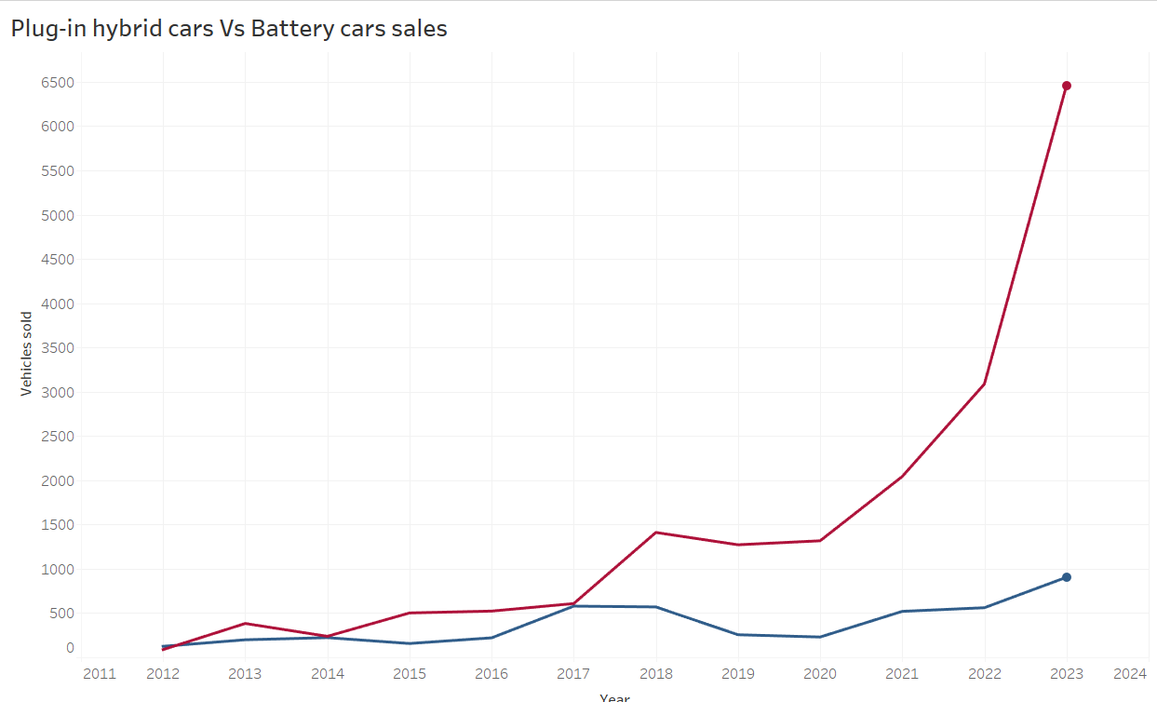

This line graph presents a comparison of sales trends between plug-in hybrid vehicles (PHEVs) and BEVs from 2011 to 2024. Battery electric vehicle sales (depicted by the red line) have seen a rapid increase, particularly since 2020, outpacing the growth rate of plug-in hybrids (blue line). This surge aligns with global movements toward zero-emission transportation solutions, where BEVs are favored due to their environmental benefits. The more moderate growth of PHEVs indicates that while they have market value, consumer preference is shifting toward fully electric options as battery technology improves, offering greater driving range and efficiency. This trend reflects a shift in consumer behavior and increased investment in EV infrastructure supporting fully electric vehicles.

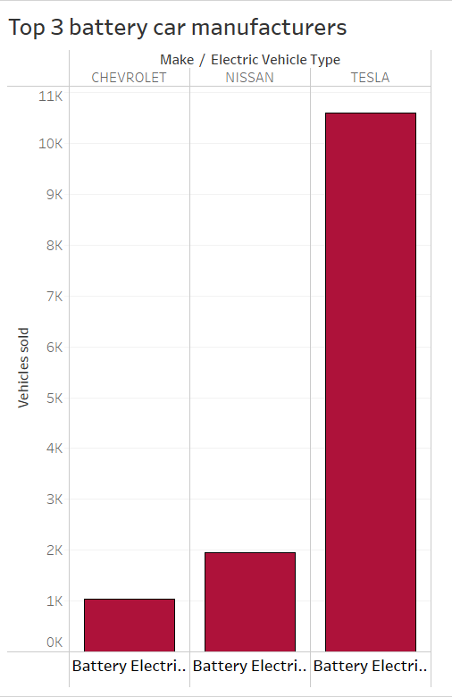

This bar chart compares the sales of battery electric vehicles (BEVs) by three leading manufacturers: Chevrolet, Nissan, and Tesla. Tesla's sales are significantly higher than those of its competitors, standing at over 11,000 vehicles, compared to approximately 3,000 and 2,000 for Nissan and Chevrolet, respectively. This disparity underscores Tesla's dominance in the BEV market and its appeal among consumers. The data suggests that while Chevrolet and Nissan have a presence in the market, Tesla’s brand recognition, technological advancements, and expanded charging infrastructure contribute to its superior performance and consumer preference.

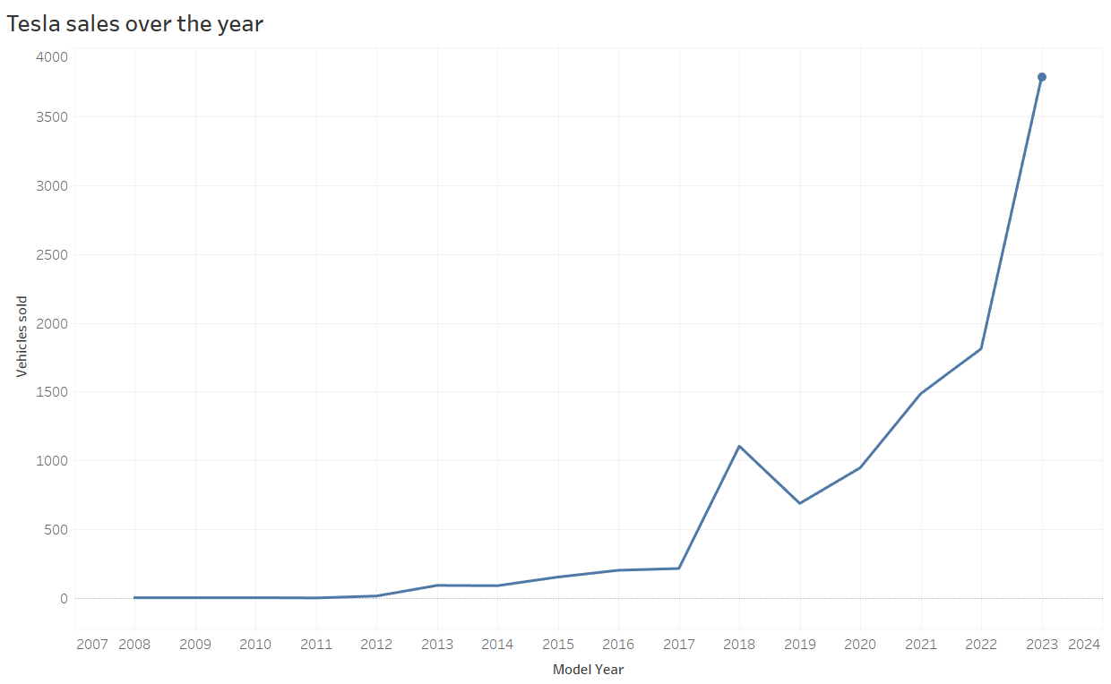

This line chart illustrates Tesla's annual vehicle sales from 2007 to 2024. Initially, Tesla’s sales were minimal, reflecting a slow adoption phase in the early years. However, from around 2018, sales began to increase substantially. This exponential rise, especially notable from 2022 onwards, aligns with heightened consumer interest, advancements in battery technology, and the expansion of EV infrastructure. The sharp growth in recent years suggests Tesla’s strong market positioning and reflects a broader shift toward sustainable vehicle options. This data highlights Tesla’s increasing role in the EV market and serves as an indicator of the growing acceptance of electric vehicles overall.

These visualizations show a strong shift toward battery electric vehicles (BEVs), with Tesla leading the way. Tesla’s rapid sales growth over the past few years mirrors a broader trend: consumers are increasingly choosing fully electric vehicles over hybrids. This shift is driven by improved battery technology, more charging options, and rising environmental awareness.

Tesla’s clear lead over competitors like Chevrolet and Nissan reflects its brand appeal and innovative edge. Overall, the data indicates that BEVs are becoming the preferred choice for sustainable transportation, and the EV market is primed for continued growth as more consumers embrace zero-emission options.

**Hypothesis 5: During the peak of COVID-19 in May 2020, consumer behaviour characterized by stockpiling and panic buying—led to a significant surge in toilet paper demand, resulting in noticeable supply shortages across major U.S. cities like California, Texas, Colorado, and New York. By contrast, in May 2019, demand was moderate and supply levels were sufficient to meet consumer needs.**

The peak of COVID-19 in May 2020 led to a major increase in demand as people stockpiled, resulting in supply shortages. In May 2019, demand was relatively low, shown here in blue, with supply levels able to meet consumer needs. By contrast, in May 2020, demand surged significantly, marked in red, indicating severe strain on supply. In this visualization, you’ll see that in 2019, demand was moderate and stable. However, in 2020, the bars turn red, illustrating the high demand and low supply conditions. Since the data shows that demand in May 2020 was indeed much higher than in May 2019, we cannot reject the hypothesis. This supports our initial expectation that COVID-19 triggered a significant increase in demand that led to shortages. This analysis highlights how a crisis can disrupt everyday essentials, underlining the need for resilient supply chains to prevent shortages in future emergencies.

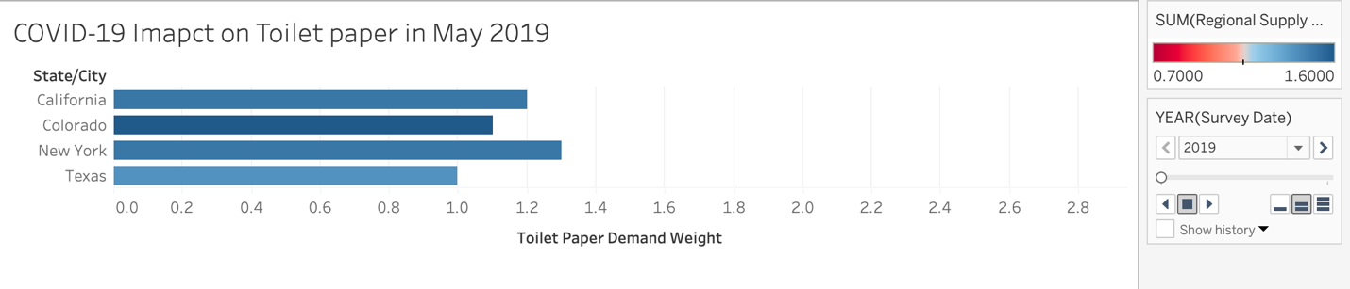

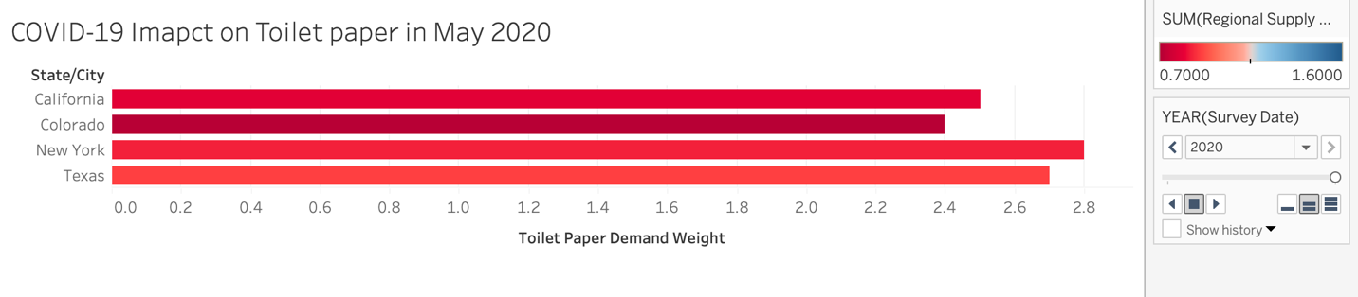

**Hypothesis 6: During September 2020 to December 2020, the state of California is the third highest with Covid-19 infection having the highest mortality adjustment rate and it shows that the performance is better than the other states.**

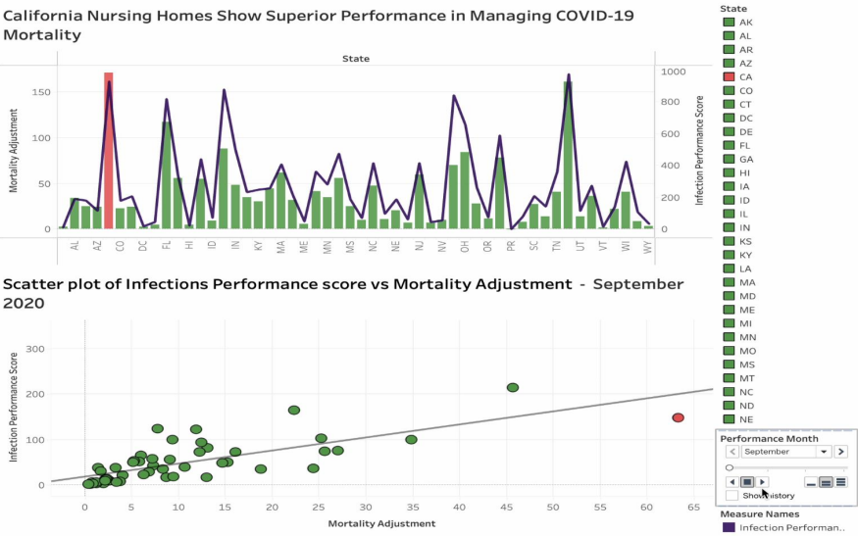

The dashboard provides insights into state-specific performance in managing COVID-19 within nursing homes, highlighting differences between California and Texas. California achieved the highest infection performance score, which may indicate a higher rate of infections compared to other states. This could be attributed to the state’s high population density, which facilitates virus transmission, and its diversified healthcare response, which likely led to more rigorous testing and reporting. Despite this, California showed higher adjustments in mortality rates, suggesting effective measures to control deaths, such as timely medical interventions, robust treatment protocols, and widespread healthcare infrastructure.

On the other hand, Texas attained the highest nursing home performance index score, reflecting superior management, resources, and adherence to protocols, which helped mitigate the spread of the virus within nursing homes. However, Texas demonstrated lower mortality adjustments than California, indicating that while it managed infections effectively, its outcomes in controlling deaths were comparatively less favorable. These findings highlight the complex interplay between infection rates, healthcare management, and mortality outcomes, emphasizing the need for state-specific strategies tailored to demographic and systemic challenges.

**CONCLUSION**

The report highlights the profound impacts of the COVID-19 pandemic on various aspects of society, economy, and market dynamics. It reveals how consumer behavior underwent significant changes, particularly in the restaurant industry, where a sharp decline in reviews reflected widespread fear and reduced social interaction during the early stages of the pandemic.

A comparative analysis of lockdown strategies in New York and Florida underscores the importance of timely public health interventions, with New York’s early measures resulting in a slower rise in cases compared to Florida’s delayed response.

Beyond the pandemic, the data also illustrates a substantial shift in the electric vehicle market, with battery electric vehicles (BEVs) gaining significant traction due to advancements in technology, increased charging infrastructure, and growing environmental consciousness. Furthermore, the surge in demand for essentials like toilet paper during the pandemic highlights vulnerabilities in supply chain systems, emphasizing the need for greater resilience in times of crisis.

Overall, the report offers valuable insights into the pandemic’s far-reaching consequences and provides lessons for effective crisis management and sustainable development.